**DCCN ISE 2**

**Group: 3**

**Prathamesh Bagekari - 2018130002**

**Akshat Bhat - 2018130003**

**Arka Haldi - 2018130014**

**TASK 1:**

**Network Topology**

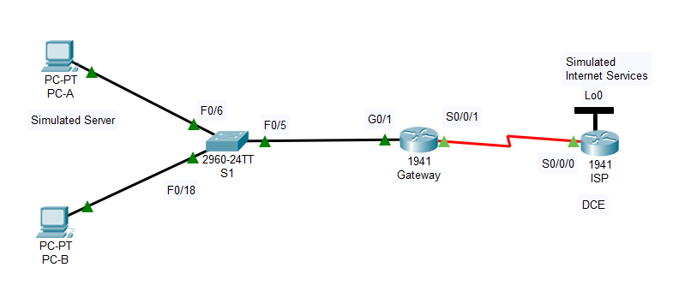

**PC-A config**

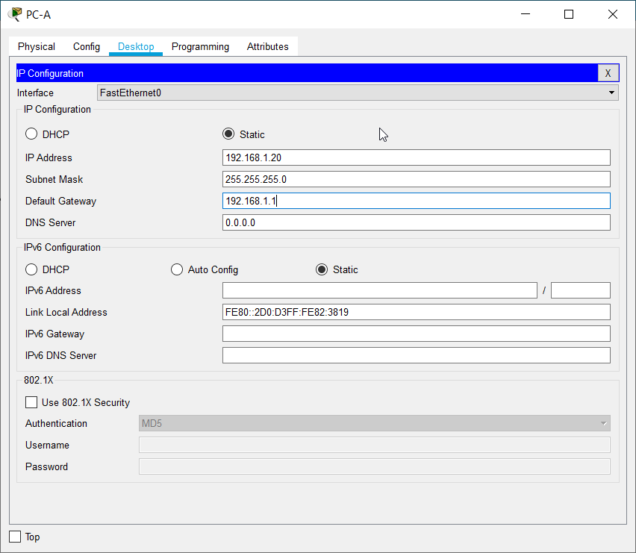

**PC-B config**

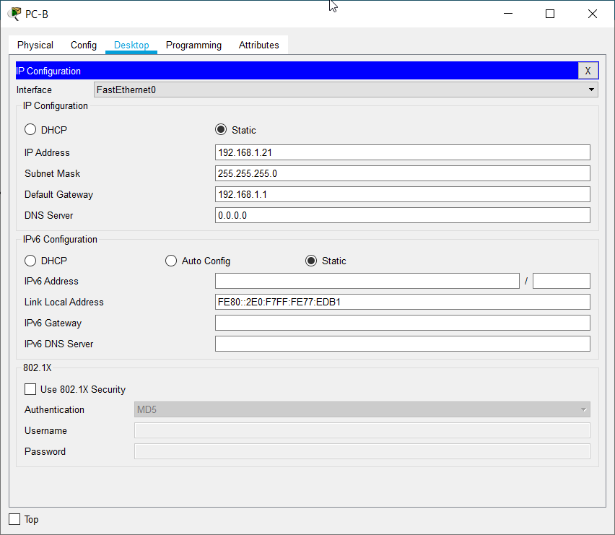

**Gateway g0/0 config**

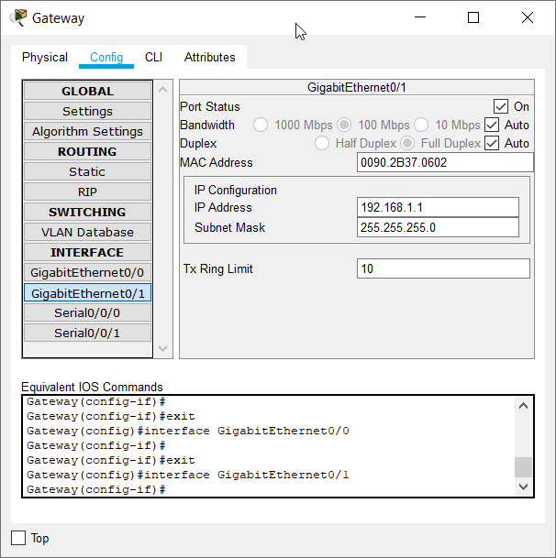

**Gateway s0/0/1**

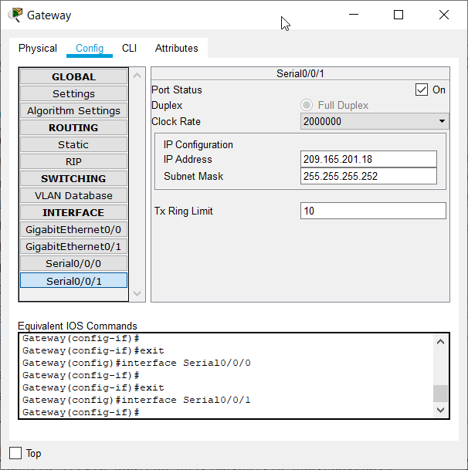

**ISP serial 0/0/0 config**

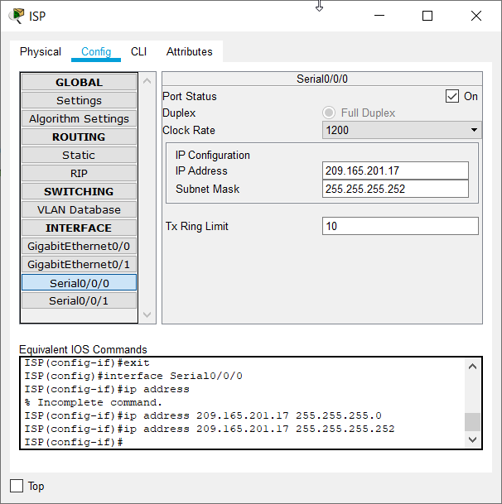

**ISP lo0 config**

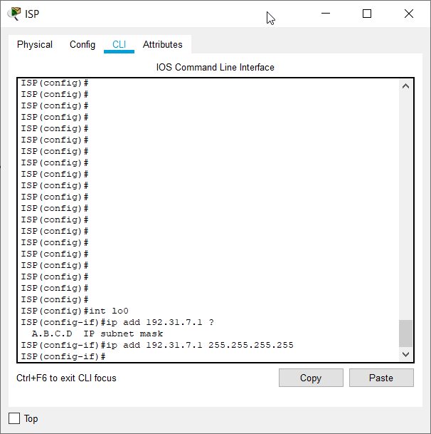

**Select right click rate for Routers**

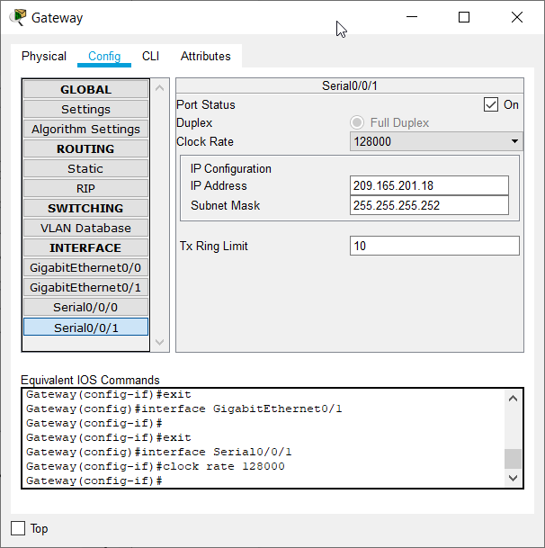

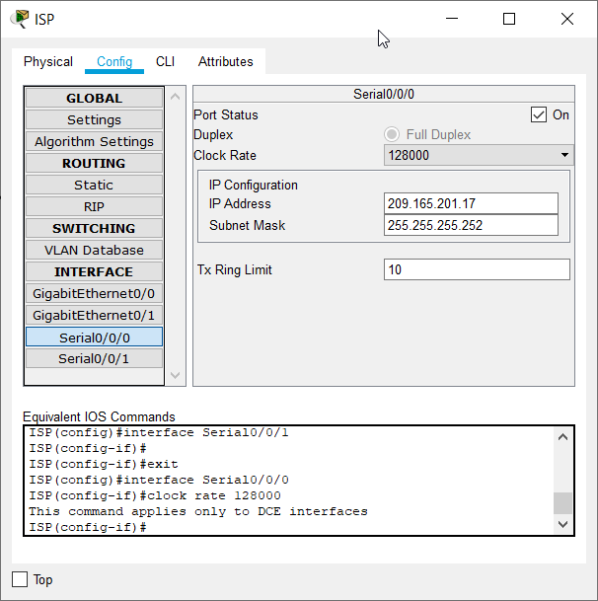

**Gateway config**

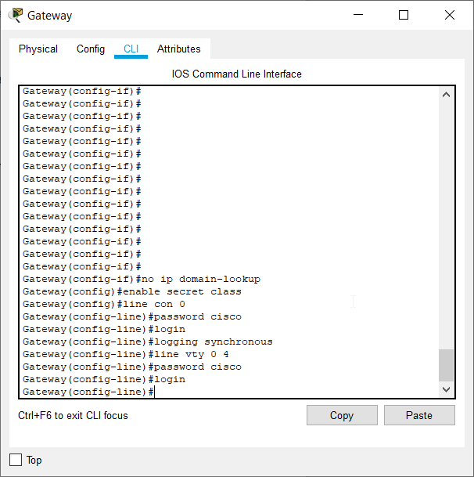

**ISP config**

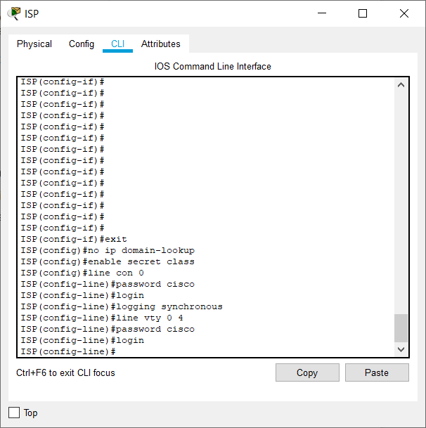

**Http error**

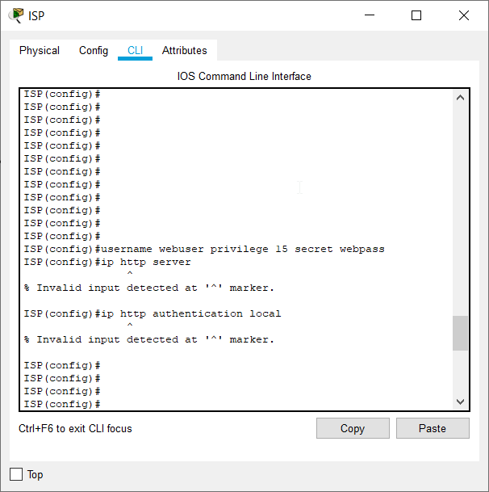

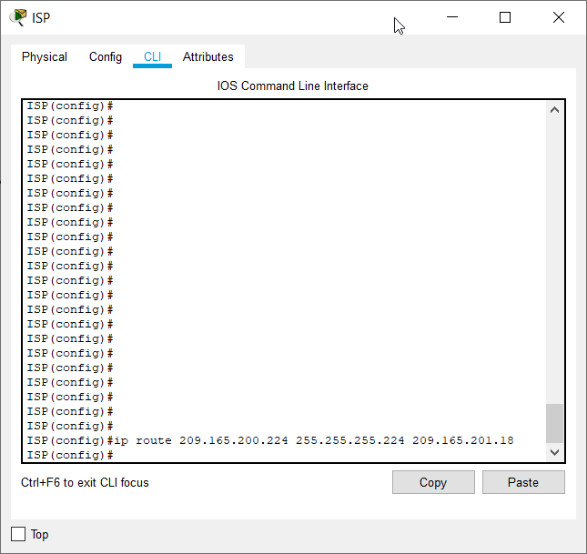

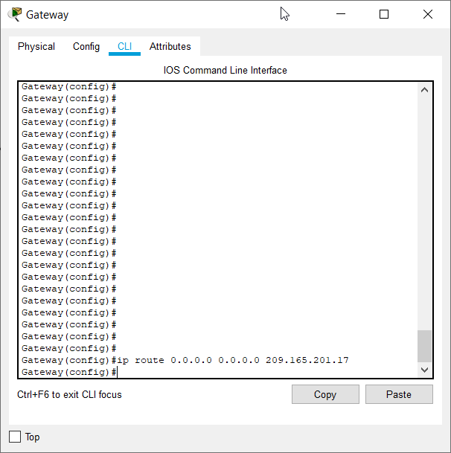

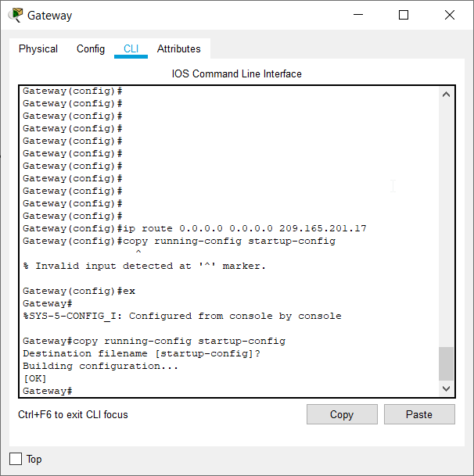

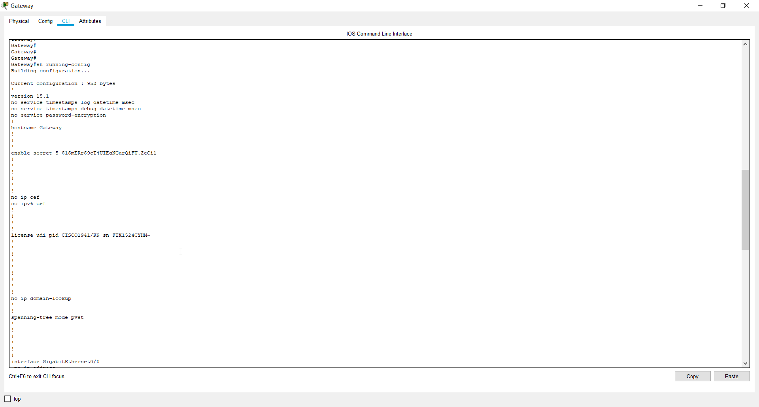

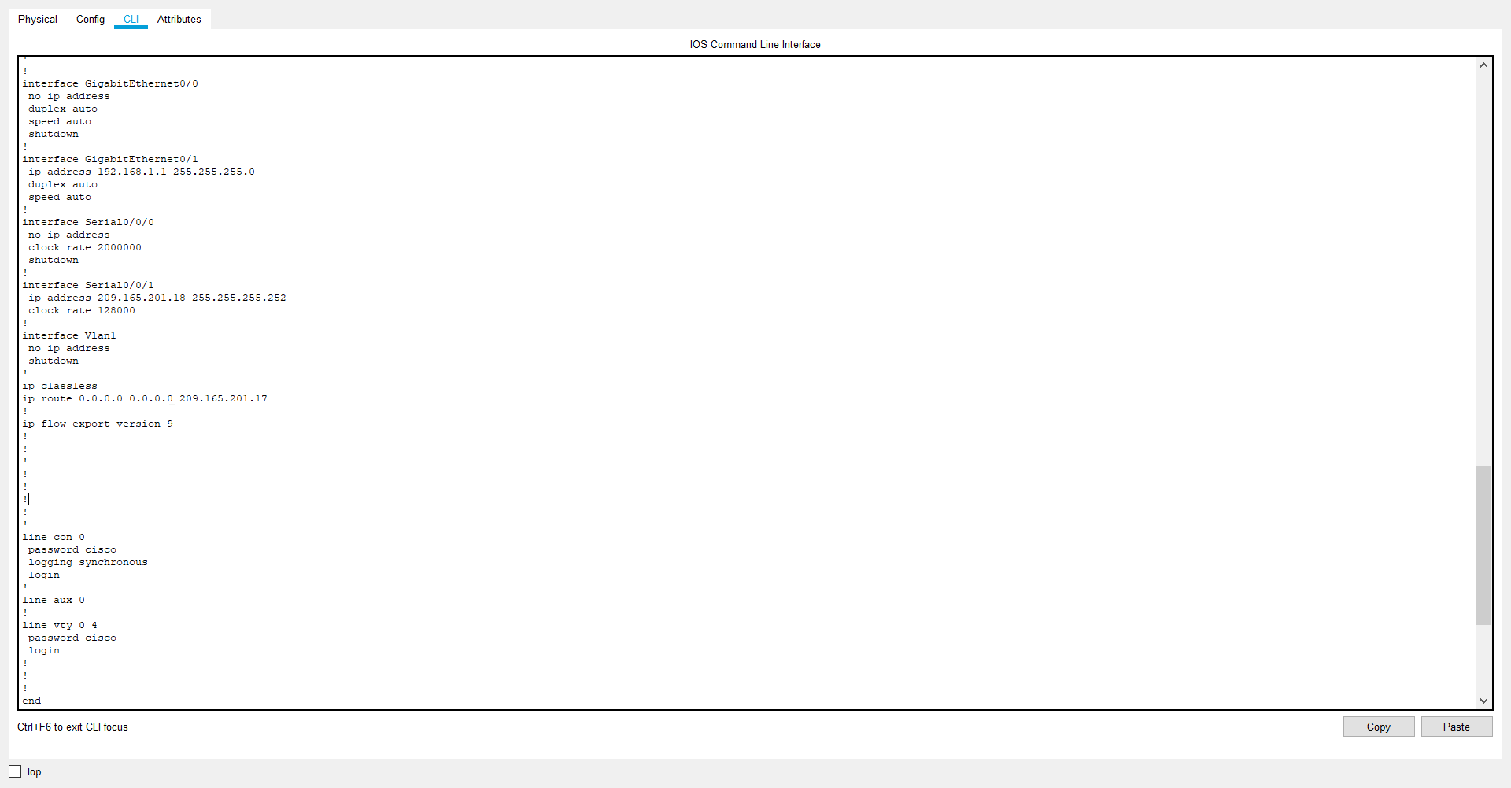

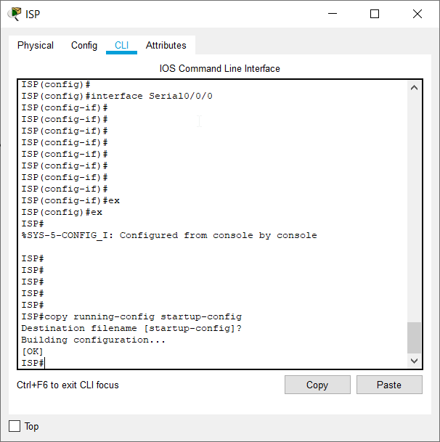

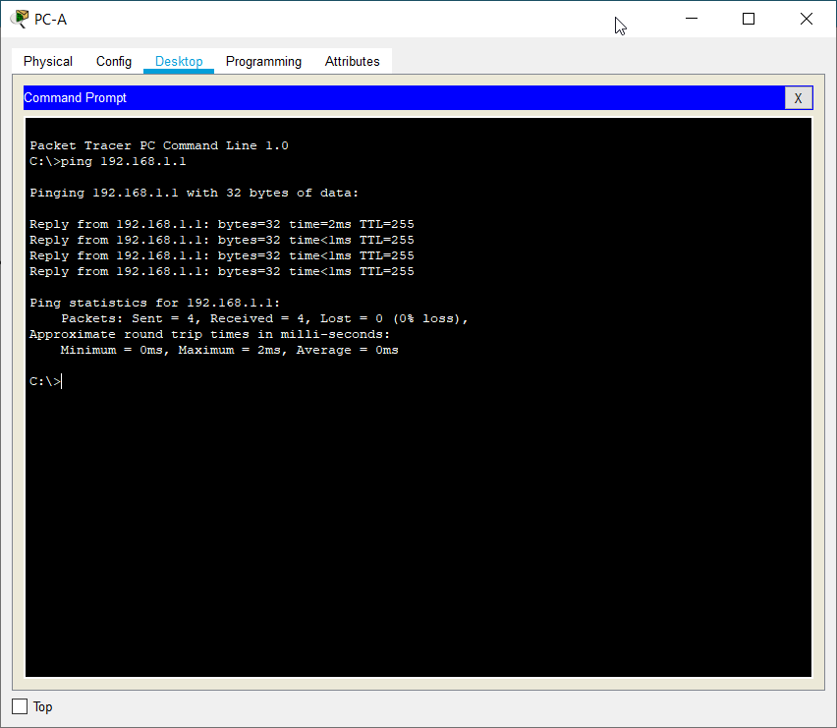

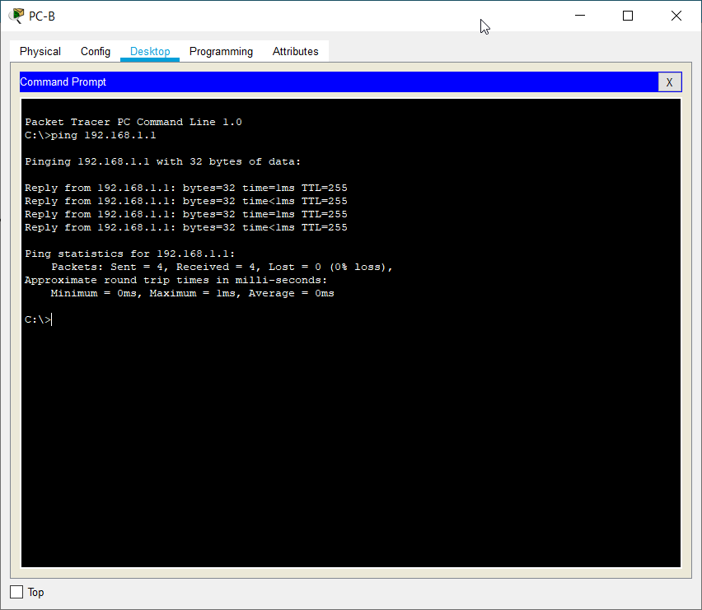

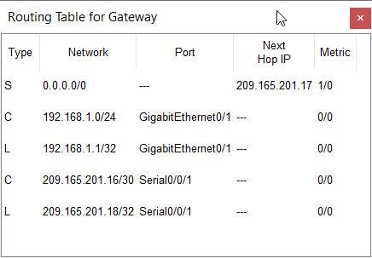

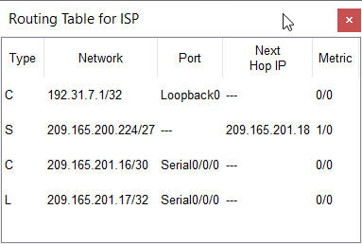

**TASK 2:**

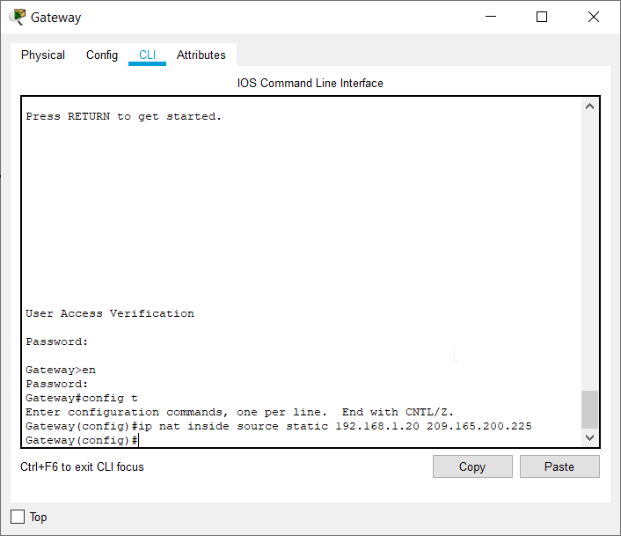

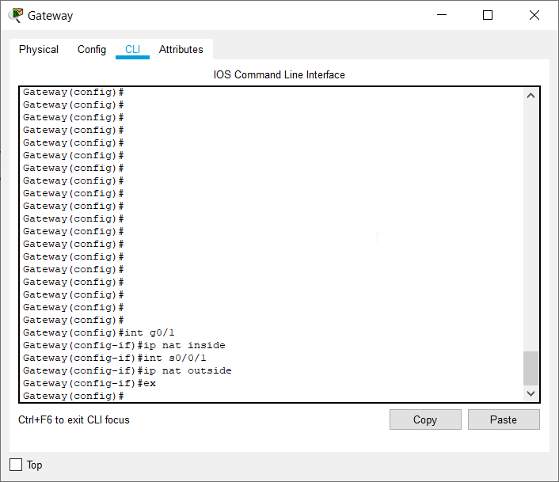

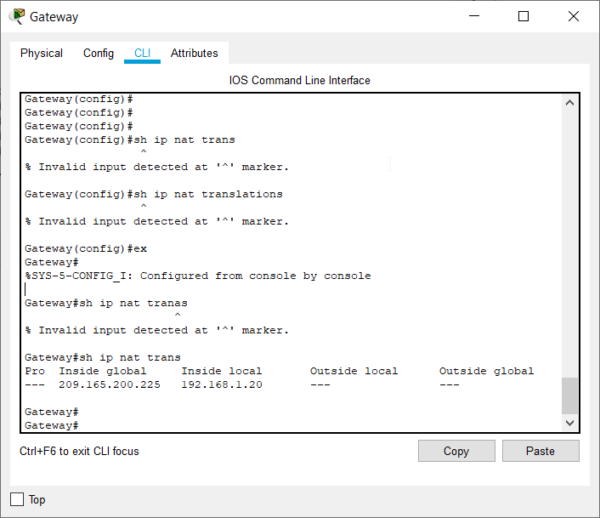

**Q.What is the translation of the Inside local host address?**

**192.168.1.20 = 209.165.200.225**

**Q.The Inside global address is assigned by?**

**ISP(static) and NAT pool(dynamic)**

**Q.The Inside local address is assigned by?**

**System Administrator**

**Pinging Lo0 interface**

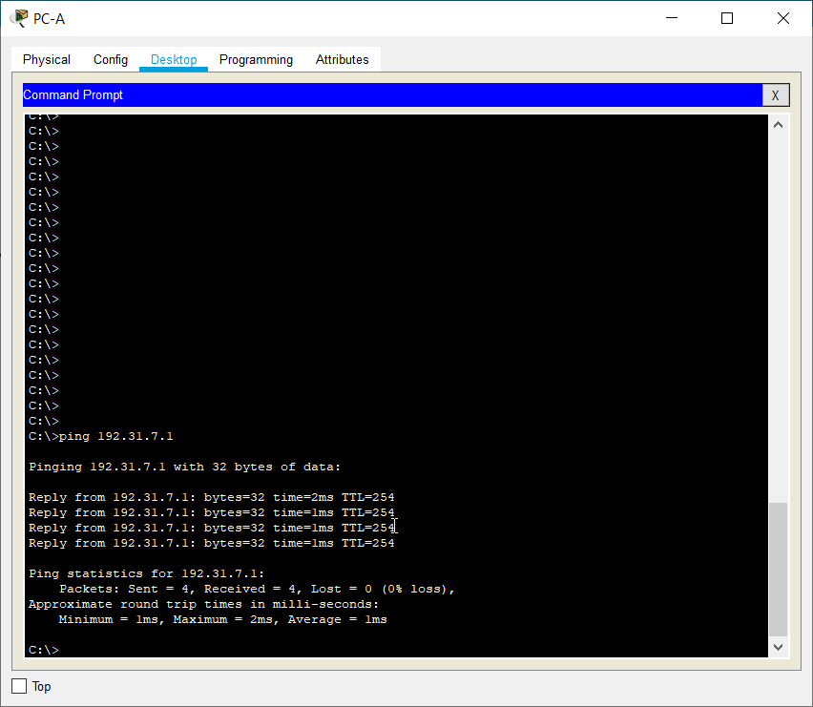

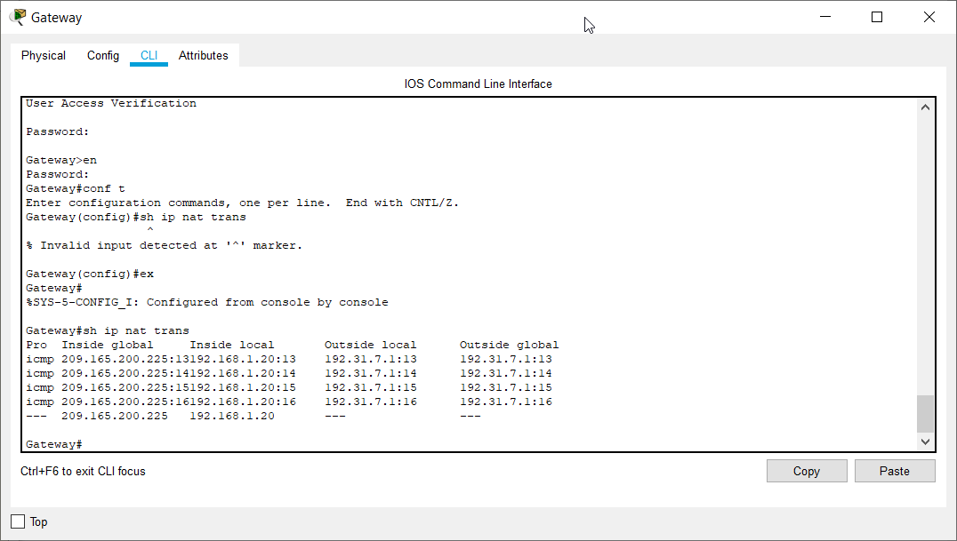

**What port number was used in this ICMP exchange?**

**4 port nos. were used for 4 ICMP exchanges for 4 pings. They are 13, 14, 15, 16.**

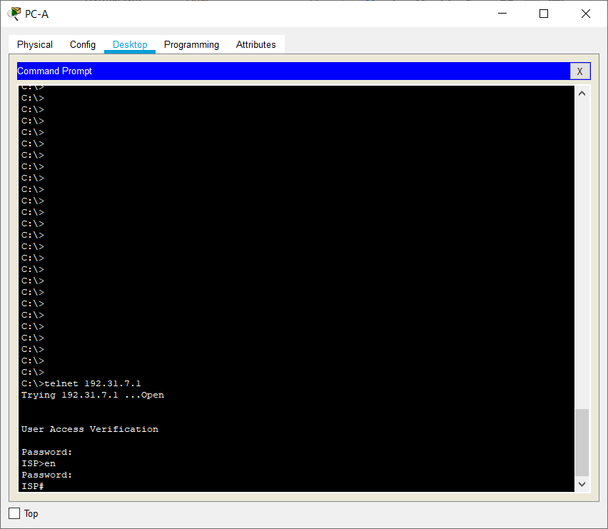

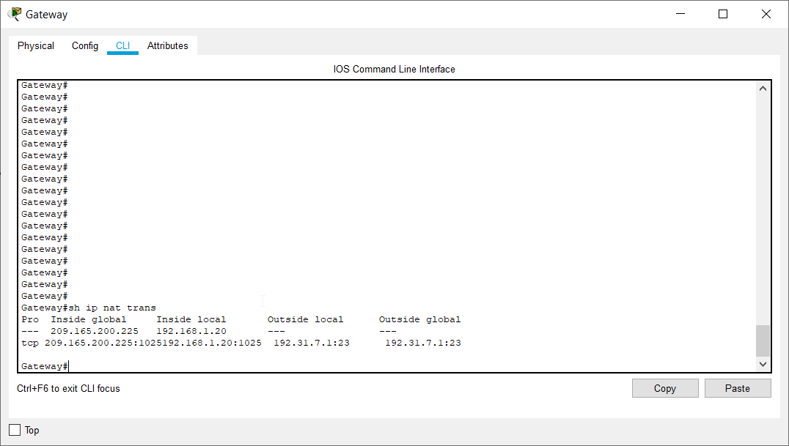

**What was the protocol used in this translation? TCP**

**What are the port numbers used?**

**Inside global / local: 1025**

**Outside global / local: 23**

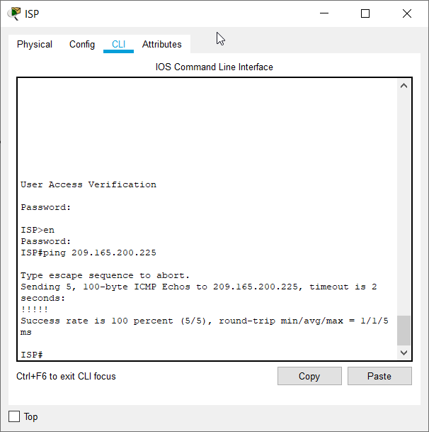

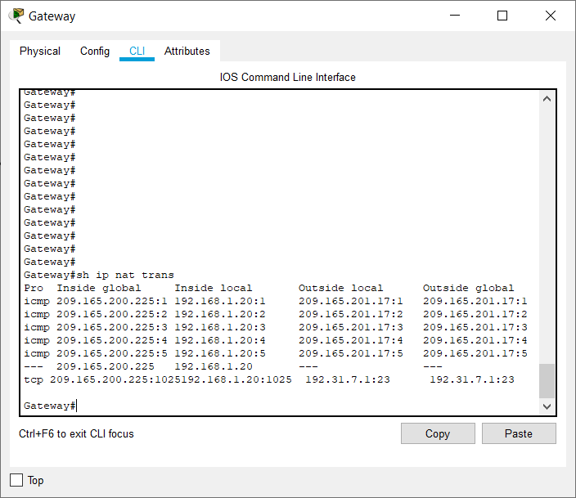

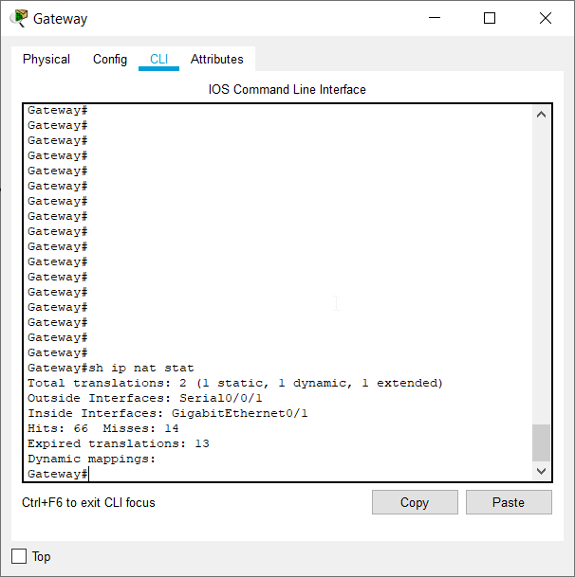

**TASK 3:**

**Clearing translations and statistics**

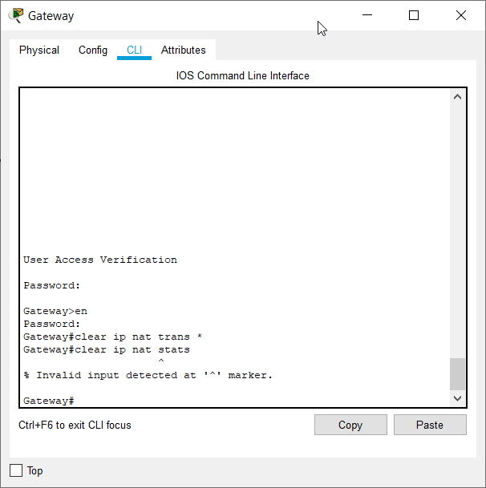

**Assign access-list 1 to range 192.168.1.0 - 192.168.1.255**

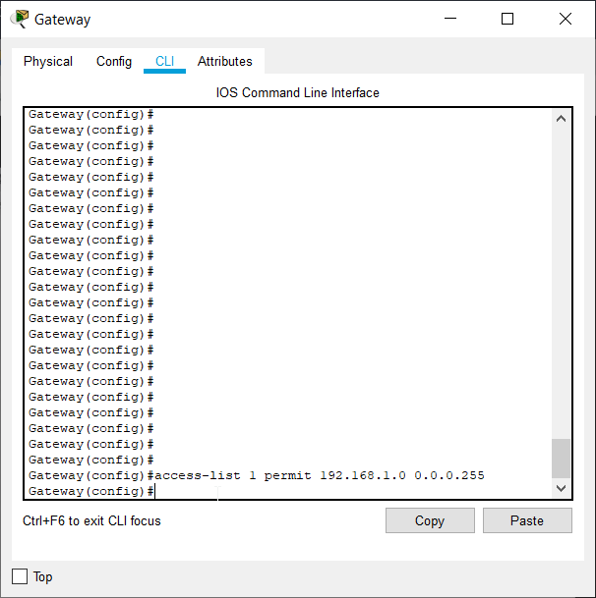

**Show nat statistics**

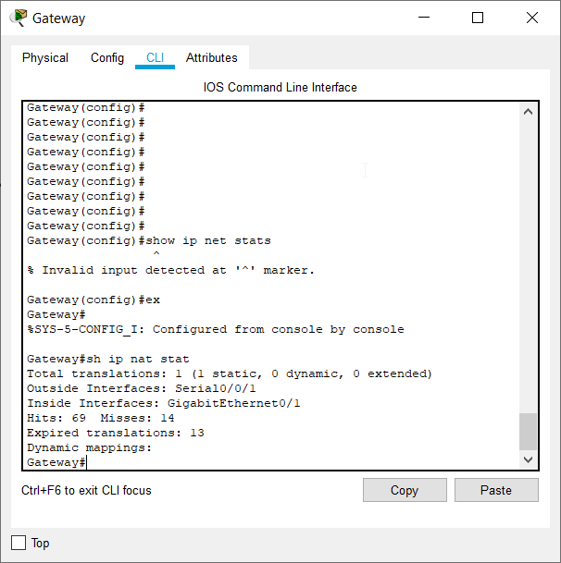

**Make nat public pool 209.165.200.242 - 209.165.200.254 netmask 255.255.255.224**

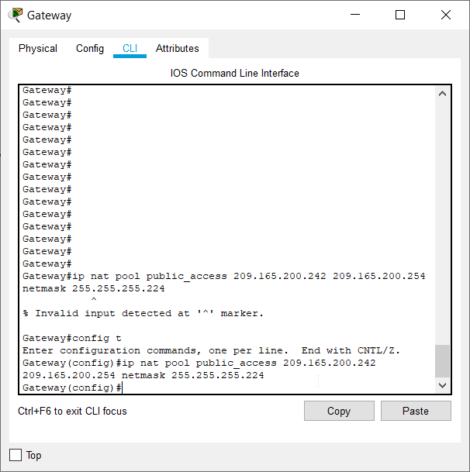

**Link inside source-list to the outer pool**

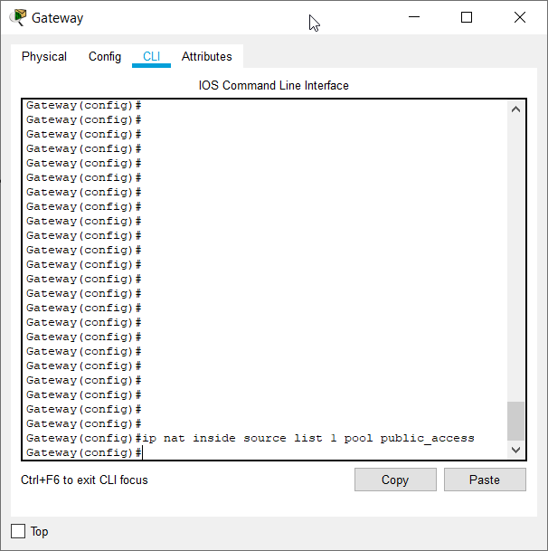

**Ping Loopback0 from PC-B**

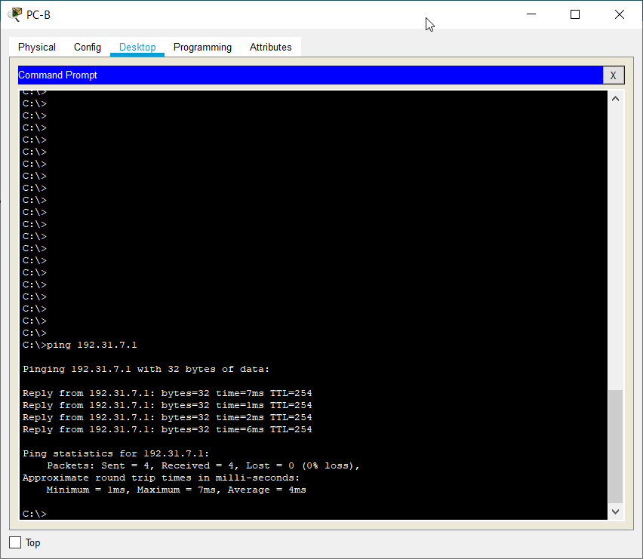

**Show NAT translation table**

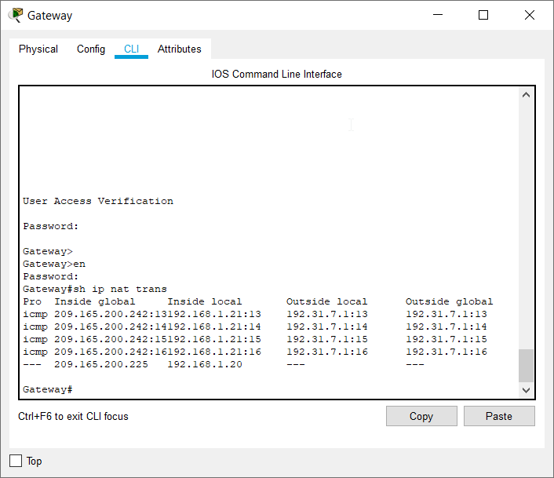

**What is the translation of the Inside local host address for PC-B?**

**192.168.1.21 = 209.165.200.242**

**A dynamic NAT entry was added to the table with ICMP as the protocol when PC-B sent an ICMP message to 192.31.7.1 on ISP. What port number was used in this ICMP exchange?**

**4 port nos. were used for 4 ICMP exchanges for 4 pings. They are 13, 14, 15, 16.**

**Removing static NAT from part 2**

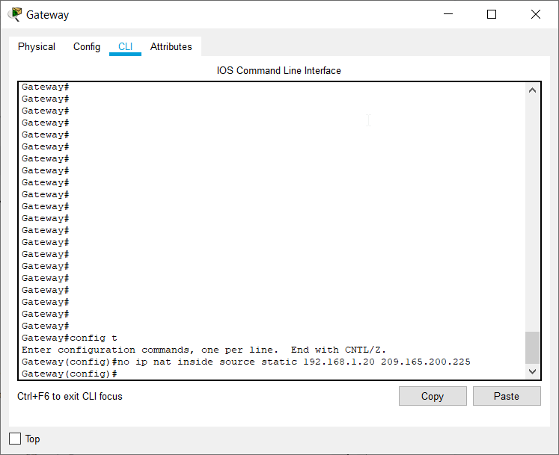

**Clear NAT and STAT**

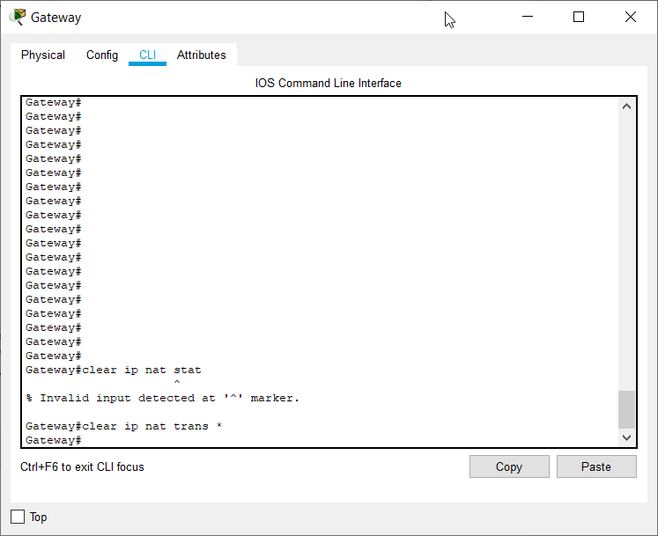

**Ping ISP from both PC’s**

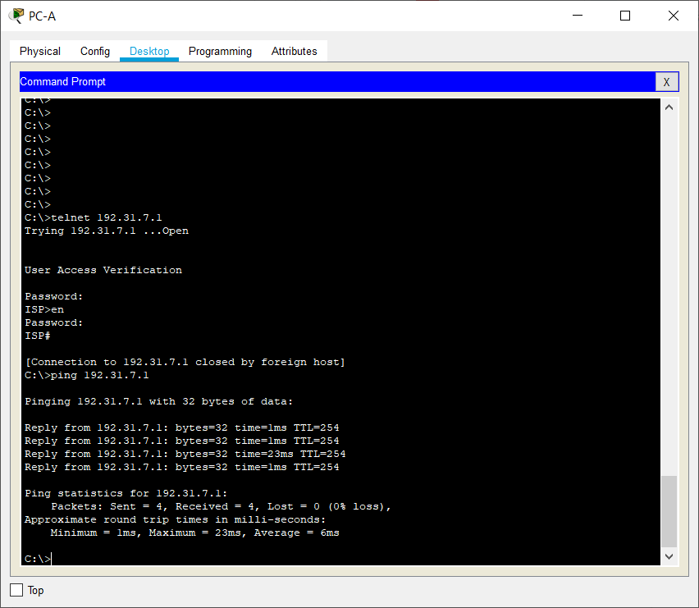

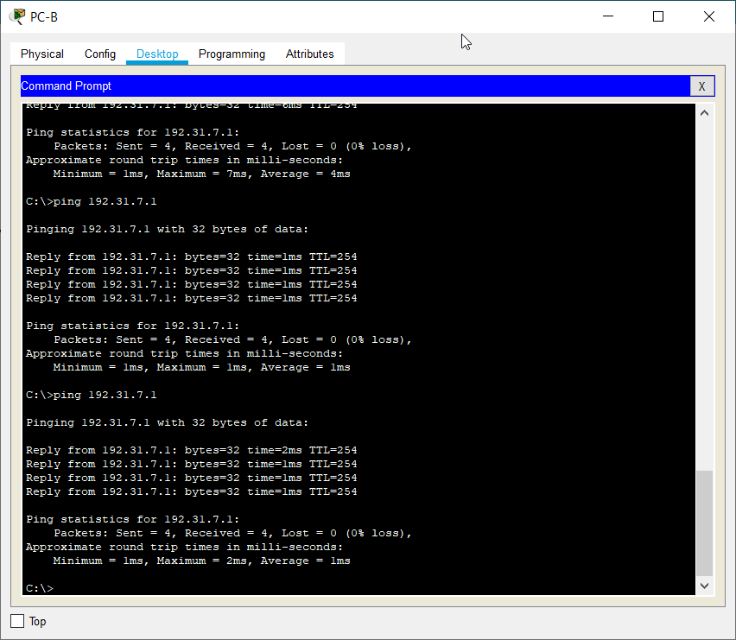

**Show NAT statistics**

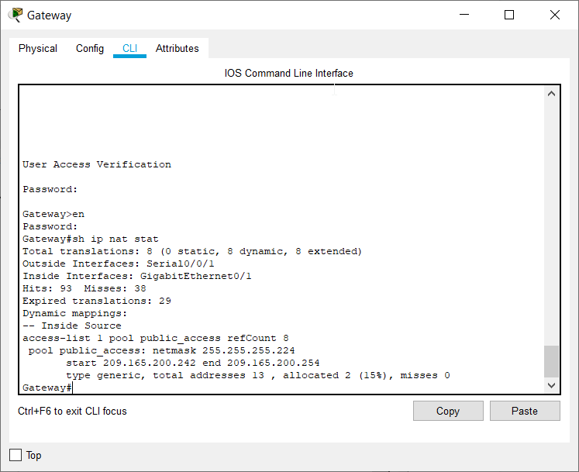

**Show nat translations**

